Experiment 3
A
Code:
import java.util.*;

class Main {
public static void main(String[] args) {

Scanner sc = new Scanner(System.in);

System.out.print("Enter Plaintext: ");
String text = sc.nextLine().toUpperCase();

System.out.print("Enter Key: ");
int key = sc.nextInt();

String cipher = "";

for (char ch : text.toCharArray()) {
if (ch >= 'A' && ch <= 'Z')
cipher += (char)((ch - 'A' + key) % 26 + 'A');
else
cipher += ch;
}

System.out.println("Ciphertext: " + cipher);

String decrypt = "";

for (char ch : cipher.toCharArray()) {
if (ch >= 'A' && ch <= 'Z')
decrypt += (char)((ch - 'A' - key + 26) % 26 + 'A');
else
decrypt += ch;
}

System.out.println("Decrypted: " + decrypt);
}
}
Output:
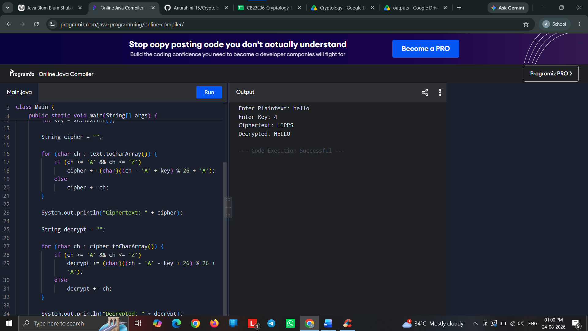

B
Code:
import java.util.*;

class Main {
public static void main(String[] args) {

Scanner sc = new Scanner(System.in);

System.out.print("Key: ");
String key = sc.nextLine().toUpperCase().replace("J", "I");

System.out.print("Text: ");
String text = sc.nextLine().toUpperCase().replace("J", "I");

String s = "";

for (char c : (key + "ABCDEFGHIKLMNOPQRSTUVWXYZ").toCharArray())
if (s.indexOf(c) == -1)
s += c;

char[][] a = new char[5][5];
int k = 0;

for (int i = 0; i < 5; i++)
for (int j = 0; j < 5; j++)
a[i][j] = s.charAt(k++);

System.out.println("\nMatrix:");
for (int i = 0; i < 5; i++) {
for (int j = 0; j < 5; j++)
System.out.print(a[i][j] + " ");
System.out.println();
}

// Add X
if (text.length() % 2 != 0)
text += "X";

String cipher = "";

for (int i = 0; i < text.length(); i += 2) {

char x = text.charAt(i);
char y = text.charAt(i + 1);

int r1 = 0, c1 = 0, r2 = 0, c2 = 0;

for (int r = 0; r < 5; r++)
for (int c = 0; c < 5; c++) {
if (a[r][c] == x) {
r1 = r; c1 = c;
}
if (a[r][c] == y) {
r2 = r; c2 = c;
}
}

if (r1 == r2) {
cipher += a[r1][(c1 + 1) % 5];
cipher += a[r2][(c2 + 1) % 5];
}
else if (c1 == c2) {
cipher += a[(r1 + 1) % 5][c1];
cipher += a[(r2 + 1) % 5][c2];
}
else {
cipher += a[r1][c2];
cipher += a[r2][c1];
}
}

System.out.println("Encrypted: " + cipher);

// Decryption
String plain = "";

for (int i = 0; i < cipher.length(); i += 2) {

char x = cipher.charAt(i);
char y = cipher.charAt(i + 1);

int r1 = 0, c1 = 0, r2 = 0, c2 = 0;

for (int r = 0; r < 5; r++)
for (int c = 0; c < 5; c++) {
if (a[r][c] == x) {
r1 = r; c1 = c;
}
if (a[r][c] == y) {
r2 = r; c2 = c;
}
}

if (r1 == r2) {
plain += a[r1][(c1 + 4) % 5];
plain += a[r2][(c2 + 4) % 5];
}
else if (c1 == c2) {
plain += a[(r1 + 4) % 5][c1];
plain += a[(r2 + 4) % 5][c2];
}
else {
plain += a[r1][c2];
plain += a[r2][c1];
}
}

System.out.println("Decrypted: " + plain);
}
}
Output:
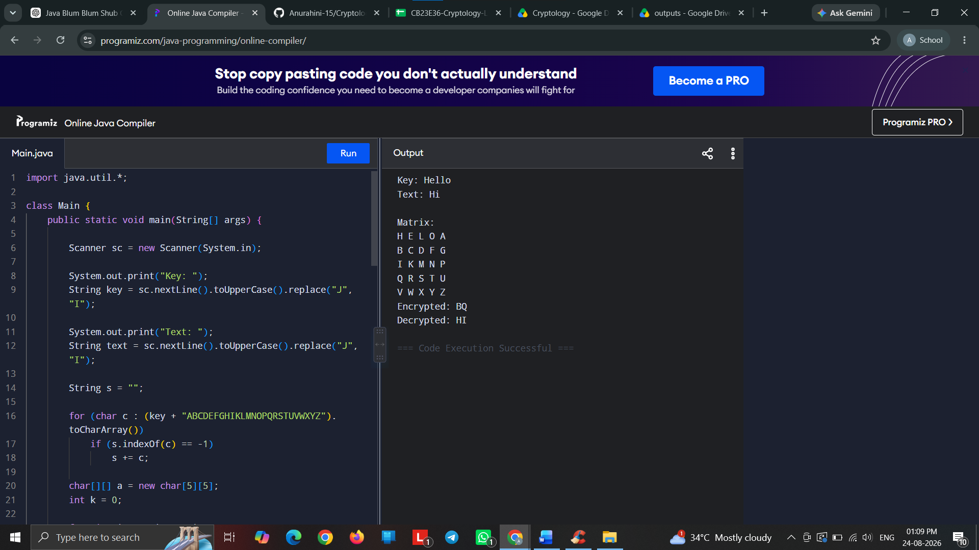

C
Code:
import java.util.*;

class Main {
public static void main(String[] args) {

Scanner sc = new Scanner(System.in);

int[][] key = {{3, 3}, {2, 5}};
int[][] inverse = {{15, 17}, {20, 9}};

System.out.print("Enter Plaintext: ");
String text = sc.nextLine().toUpperCase().replace(" ", "");

if (text.length() % 2 != 0)
text += "X";

String cipher = "";

// Encryption
for (int i = 0; i < text.length(); i += 2) {

int a = text.charAt(i) - 'A';
int b = text.charAt(i + 1) - 'A';

int x = (3 * a + 3 * b) % 26;
int y = (2 * a + 5 * b) % 26;

cipher += (char)(x + 'A');
cipher += (char)(y + 'A');
}

System.out.println("Ciphertext : " + cipher);

String plain = "";

// Decryption
for (int i = 0; i < cipher.length(); i += 2) {

int a = cipher.charAt(i) - 'A';
int b = cipher.charAt(i + 1) - 'A';

int x = (15 * a + 17 * b) % 26;
int y = (20 * a + 9 * b) % 26;

plain += (char)(x + 'A');
plain += (char)(y + 'A');
}

System.out.println("Decrypted : " + plain);
}
}
Output:
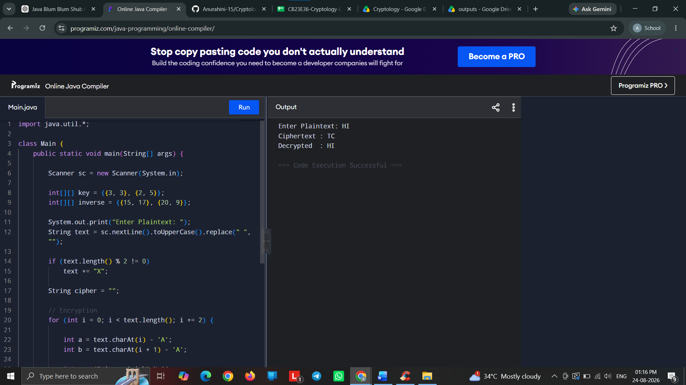

D
Code:
import java.util.*;

class Main {
public static void main(String[] args) {

Scanner sc = new Scanner(System.in);

System.out.print("Enter Plaintext: ");
String text = sc.nextLine().toUpperCase();

System.out.print("Enter Keyword: ");
String keyword = sc.nextLine().toUpperCase();

String key = "";

for (int i = 0; i < text.length(); i++)
key += keyword.charAt(i % keyword.length());

String cipher = "";

// Encryption
for (int i = 0; i < text.length(); i++) {
int x = (text.charAt(i) - 'A' + key.charAt(i) - 'A') % 26;
cipher += (char)(x + 'A');
}

System.out.println("Generated Key: " + key);
System.out.println("Ciphertext: " + cipher);

String plain = "";

// Decryption
for (int i = 0; i < cipher.length(); i++) {
int x = (cipher.charAt(i) - 'A' - key.charAt(i) + 'A' + 26) % 26;
plain += (char)(x + 'A');
}

System.out.println("Decrypted: " + plain);
}
}
Output:
